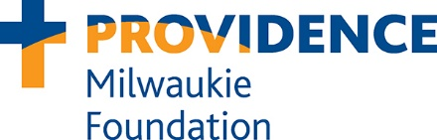

Your Support Matters
Providence Milwaukie Foundation

Providence Milwaukie Foundation connects generous donors with Providence Milwaukie Hospital to advance health and wellness in our community and care for the poor and vulnerable. We are the bridge between you and Providence caregivers working every day to save and improve peoples’ lives.

Donors to our foundation advance programs that rely on philanthropy, programs that require only seed money, and programs that thrive because of the margin of excellence their gifts provide.
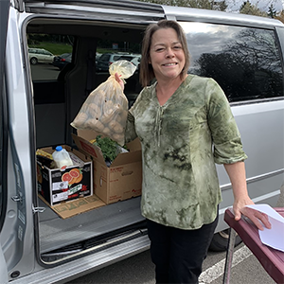
Among many ways they have helped our patients, our donors have helped to train more than 100 much-needed family physicians through residencies in our hospital. They have helped community members address food insecurity and incorporate healthy food into their diets. And, they have ensured that newborns benefit from breast feeding and overcome challenges like jaundice and weight loss.

How you can help
Today, the health care needs of our community continue to grow and change. Our patients need your support more than ever before. Here are a few ways you can make a difference:

- Emilie Gamelin Fund: Support patients and their families within the Providence Milwaukie service area by providing basic needs such as prescription medication, temporary housing, transportation, food vouchers, clothing and more.
- Community Teaching Kitchen and Family Market: Support the community by offering one-on-one and small group outpatient nutrition counseling, diabetes education, regular screening for food insecurity, and access to a navigator for individualized resources. The Community Teaching Kitchen includes a Family Market that provides a wide variety of foods to help families who are facing hunger.
- Caregiver education: Ensure that our patients continue to receive care from a dedicated team of compassionate and well-trained caregivers by partnering with Providence to provide scholarships for health care degree and certificate programs.
- Family medicine residency program: Provide additional educational opportunities for medical residents in the Oregon Family Medicine Residency, which has produced 25% of the family medicine doctors practicing in Oregon today.

For more information about how you can advance the health and wellness of our community, please contact Tiffany Gillespie at 503-650-6809 or Tiffany.Gillespie@providence.org.

Providence Oregon
Providence Milwaukie Hospital is part of Providence Oregon, a not-for-profit network of hospitals and centers, health plans, physicians, clinics, home health services, and affiliated services operating throughout Oregon. Our caregivers pledge to care for all people who come for services and to seek out the unmet needs of those who lack essentials. In total, we serve more than one million people in Oregon and southwest Washington.

OUR MISSION
As expressions of God’s healing love, witnessed through the ministry of Jesus, we are steadfast in serving all, especially those who are poor and vulnerable.

OUR VALUES
Compassion, Dignity, Justice, Excellence, Integrity

ProvidenceFoundations.org/milwaukie

